**GIT Remoting**

**Objective:** Pushing source code into GITHUB & collaborate team members.

SECTION-1 (Pushing assignments to remote repository) - Steps to follow:

**39. Create a GitHub account if you do not have already.**

GitHub Account link: <https://github.com/Aniket7narale/Assignments.git>

40. Login on into github account.

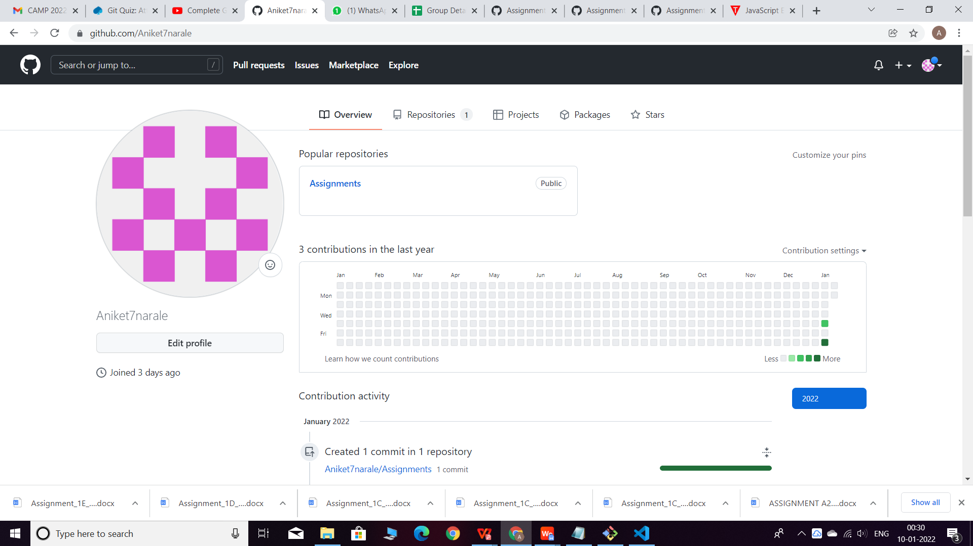

1. Create new public repository ‘freshersbatch-oct16’.

